
Imparting skills to drive change!

ASSIGNMENT 3.
Date: November 17th, 2019.

STUDENT NAME: Obwon Enock

COURSE: POST GRADUATE DIPLOMA IN WATER RESOURCES MANAGEMENT

MODULE THREE.
Topics
- Water Treatment
- Sewerage Systems

Skype: enock.obwon
Cell Phone: +256 787 970 056
Email.: enock@4-africa.com/enoch2054@gmail.com

- Once installed, does water treatment equipment require any service? Justify your answer by an explanation
Water treatment equipment definitely require routine service, so as to ensure the treatment plant produces desired quality & quantity of treated water which meets current regulations, while making sure the plant equipment continues to work efficiently to achieve its operational objectives.
Water and wastewater treatment plants are no longer traditional plants; monitoring is not just taste, odor, iron and manganese; water treatment facilities are more complex now days, new technologies have emerged, raw water is more difficult to treat, the treatment requires more innovative solutions, there is an increasing demand for services, diminishing resources, rising service expectations of customers and increasingly stringent regulatory requirements. This all leads to analyzing and enhancing the way we look at operation and maintenance in the water and wastewater industry and the treatment facilities that should be developed and expanded to accommodate these dramatic changes (Mufid, 2014).
- If well water tests positive for coliform bacteria, what is the implication of that and what does it call for?
The detection of coliform bacteria in water at levels greater than 0.00 CFU/100 mL is an indicator of feacal pollution of the well water, this therefore means the level of sanitation within the community is therefore poor and open defecation is common (Emmanuel et al, 2013).
The first step in protecting the well water is by emphasizing household sanitation in that pit latrines should at least be 50 meters away from water source & discouraging open defecation, the second step is the development of a watershed or wellhead protection program.
Controlling or eliminating microbial sources before they contaminate a water supply will go a long way toward simplifying treatment and reducing costs associated with a contaminated supply the catchment around the well should also be protected so as to avoid the occurrences of contamination. Water well should also be disinfected at source and also be treated at household level using appropriate technologies such as boiling or use of Point of Use water treatment such as use of Bio Sand filters
- Explain the sources of microbes that cause contamination to water and possibly how the same can be treated
Microbes are microscopic creatures such as bacteria, viruses, & protozoa, that are disease causing agents, the following therefore are sources of microbes that cause contamination to water
Sewage Disposal Systems
Failing sewage disposal systems represent the major source of microbial contamination from human waste. This includes large municipal waste treatment systems, pump stations, and malfunctioning on-site sewage treatment systems like cesspools, septic tanks, and leach fields.
Agriculture
Runoff carrying animal waste from barnyards, manure storage areas, dairy farms, pig farms, pastures, and the land application of manure is a significant source of microbial contamination
Storm water Runoff
Rainwater and snowmelt flow over the land picking up pollutants and deposit them into water supplies. Runoff can also pick up microbial contaminants from suburban environments such as pet waste on sidewalks
Wildlife
Wildlife is an integral part of a balanced watershed. However, birds and mammals can introduce microorganisms into a water supply either through direct contact or from watershed runoff. Giardia, cryptosporidium, salmonella, campylobacter, and Escherichia coli (E.coli) are the most commonly identified microorganisms found in mammals and birds. Wildlife commonly associated with microbial contamination of drinking water supplies include: deer, beavers, muskrats, gulls, and geese.
Microbes when ingested in drinking water can cause a number of infectious waterborne diseases such as cholera, typhoid, hepatitis, and infectious gastrointestinal diseases like cryptosporidiosis and giardiasis, symptoms of waterborne disease may include fever, fatigue and weight loss (common in viral cases), vomiting, abdominal cramping, diarrhea, and stomachaches. In the most severe cases waterborne diseases can prove lethal.
Therefore, some microbial contaminants can be removed by water treatment coagulation and filtration processes. Disinfection has been proven effective against bacteria and viruses, but protozoa, such as Cryptosporidium, are very resistant to chlorination alone. Other treatment methods have been used to address Cryptosporidium such as ozonation, & UV disinfection.
- Boiling water has been termed as the most convenient way of preserving water in small household in the rural set up. Do you agree? Justify your answer by a brief discussion
Boiling water is the safest way to disinfect water in rural household which I do clearly agree with. The World Health Organization therefore recommends Vigorously boiling water as that kills or inactivates most organisms that would cause diarrhea in the households. Boiled water therefore, is not stored in the containers where it was boiled rather it’s filtered to another clean container where its left to cool down before it can consumed.
- Explain how fluorides can get into contact with drinking water, how they are destructive and how water that contains fluorides can be made safe for human consumption
Naturally occurring fluoride is found in groundwater worldwide. Geologic areas containing marine sedimentary rocks (usually in mountains), volcanic rocks, and igneous and metamorphic rocks such as granites and gneisses rich with fluorite, apatite and/or mica typically contain groundwater with high levels of fluoride. A belt of sedimentary rock located from Iraq through Turkey and also in Morocco influences groundwater concentrations of fluoride throughout that region. The most well-known case of volcanic rocks causing high fluoride levels is in the Rift Valley of East Africa where fluoride levels of over 2000 mg/L are present in some lakes. Regions with granites and gneisses include India, Pakistan, China, West Africa, Thailand and Southern Africa (Fawell et al. 2006).
The latest estimates suggest that around 200 million people, from among 25 nations the world over, are under the dreadful fate of fluorosis. India and China, the two most populous countries of the world, are the worst affected. India is plagued with numerous water quality problems due to prolific contaminants mainly of geogenic origin and fluoride stands first among them. The weathering of primary rocks and leaching of fluoride-containing minerals in soils yield fluoride rich groundwater in India which is generally associated with low calcium content and high bicarbonate ions. The unfettered ground water tapping exacerbates the failure of drinking water sources and accelerates the entry of fluoride into groundwater (Ayoob et al, 2006).
Therefore, the most common health-effect associated with long-term ingestion of high concentrations of fluoride (above 1.5mg/l, the WHO guideline value) is fluorosis of the teeth and bones (Katherine, 2012).
Low cost treatment of fluorides includes the use of Nalgonda system (which uses lime water to soften the water), and using alum as a coagulant. the water is then left to settle at the same time it is being chlorinated.
- Briefly discuss why it is unwise for drinking water to be in contact with sewerage
It is unwise for drinking water to get in contact with sewerage as it can get contaminated through infrastructure breaks, leaks and also in cross connections as a result of faulty construction, pressure transients, repairs & replacement activities as well as permeable pipe materials also present routes for exposing drinking water to contamination where harmful and potentially deadly bacteria can infect drinking water and it becomes a health hazard, the bacteria in human waste such as E Coli can infect the water and cause diseases
- Briefly discuss the types of sewerage system discussed and their applicability
The sewerage systems or water carriage systems are of the following three types:
a). Separate System
b). Combined System
c). Partially Separate System.

a. Separate System:
In this system two sets of sewers are provided-one for carrying domestic or sanitary sewage and industrial sewage, and the other for carrying storm water (or surface runoff). The sewage from the first set of sewers is carried to the treatment plant for adequate treatment before its discharged into the water body or used for irrigation to meet desired standards, and the storm water (or rain water) from the second set of sewers is directly discharged into a natural stream or river without any treatment since the run off is not as foul as sewage. Separate system is therefore advantageous and economical for big towns.
Conditions Favorable for Separate System
The separate system is therefore favored under the following conditions
(i) Uneven Rainfall
When rainfall is uneven or it is concentrated for a short period during the year, it becomes economical to adopt separate system.
(ii) Separate Outlets for Sewage and Storm Water (or Rain Water)
The separate system can be justified when domestic or sanitary sewage and industrial sewage is to be collected and conveyed to a particular point for treatment and there is a separate outlet in the form of a natural stream or river for the disposal of storm water (or rain water).
(iii) Pumping Requirement
When it is necessary to pump domestic or sanitary sewage and industrial sewage, adoption of this system will reduce the load on pumps.
(iv) Limitations of Available Funds
If sufficient funds are not available in the beginning, sewers may be constructed to carry only domestic or sanitary sewage and industrial sewage, and the storm water (or rain water) may be conveyed through open drains. These drains can be converted into regular sewers later when additional funds are available.
(v) Flat Topography
If the area is flat, the sewers will have to be laid at a certain depth below the ground surface in order to achieve the required gradient. In such cases separate sewers are more economical, because laying of a combined sewer of larger size at a greater depth below the ground surface will be costly.
(vi) Gradient of Sewers
If it is not possible to lay sewers at suitable gradients, there is a danger of backing up of sewage into the houses. Under such circumstances, it is desirable to adopt separate system.
(vii) Subsoil Condition
If the subsoil is hard, it would be difficult and costlier to lay combined sewer which is usually of large size. Thus in such cases separate system would be preferable.
(viii) Steep Topography
If the area possesses steep slopes, it would be easier to convey storm water (or rain water) through open drains to the natural stream or river, and hence separate system may be adopted.
(ix) Time of Laying Sewers
If sewers are to be laid before the area is developed, it is desirable to adopt separate system.
(x) Conversion of Existing Sewer
It is not desirable to convert the existing sewer for carrying domestic or sanitary sewage and industrial sewage into a combined sewer because it becomes costly and it is also inconvenient. In such a case it is better to lay a separate sewer for storm water (or rain water).
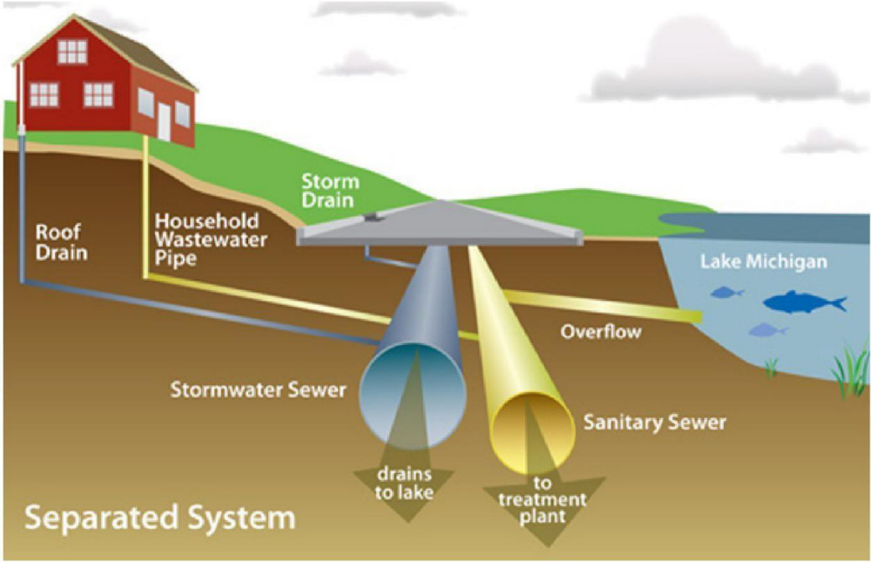
Source: Module Three Notes, PGD in Water Resources Mgt.

b. Combined System:
In this system only one set of sewers is provided for carrying domestic or sanitary sewage and industrial sewage as well as storm water (or rain water). Thus in this case sewage and storm water (or rain water) are carried to the sewage treatment plant before its final disposal to a stream or water body
Conditions Favorable for Combined System
The combined system is therefore favored under the following conditions
(i) Even Rainfall
If rainfall is evenly spread throughout the year, the combined system can be adopted.
(ii) Pumping Requirement
When it is necessary to pump domestic or sanitary sewage and industrial sewage as well as storm water (or rain water), the combined system may be adopted.
(iii) Restriction of Space
When space available for laying sewers is restricted, it is desirable to lay a combined sewer.
(iv) Conversion of Existing Storm Water Sewer
If existing storm water sewer may be converted into a combined sewer, then combined system may be preferred. However, such a conversion will be possible only when the quantity of domestic or sanitary sewage and industrial sewage is small as compared to that of storm water (or rain water).
It may, however, be mentioned that the combined system of sewerage has not been found quite suitable under tropical Indian conditions for reasons mentioned below:
(i) Heavy and concentrated rainfall occurs during the monsoon period, which at most places lasts for only 3 to 4 months in a year. Thus there is a large variation in the quantity of sewage flowing during the different months of the year.
(ii) The Dry Weather Flow (D.W.F) is generally a very small proportion of the total flow and hence sewer is likely to get silted up due to low velocity of flow.
(iii) Poor economy and limited funds being available.
(iv) There are difficulties in operation and maintenance of the system due to poor supervision of less qualified staff. Also the municipalities or local bodies in charge of the works normally do not pay much attention to keep trained and skilled staff.
Because of the aforesaid reasons the usual practice is to adopt either separate system of sewerage or partially separate system of sewerage.
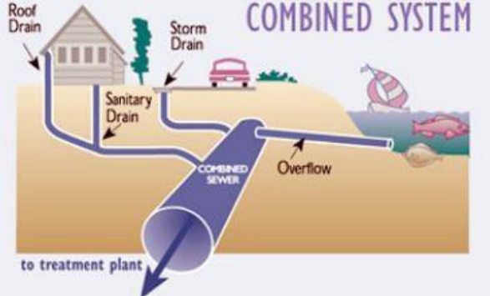
Source: Module Three Notes, PGD in Water Resources Mgt.

c). Partially Separate System:
In this system domestic or sanitary sewage and industrial sewage, and the storm water (or rain water) which is drained from back yards and roofs of houses are carried in the same set of sewers, while the storm water (or rain water) drained from house fronts as well as from streets and roads is collected and conveyed in a separate set of open drains.
The sewage and storm water (or rain water) carried by the sewers is usually delivered to a sewage treatment plant, and the storm water (or rain water) carried by the open drains is delivered to a natural stream or river for disposal
Advantages of Partially Separate System
The partially separate system has the following advantages
(i) It combines the advantages of both separate system and combined system.
(ii) The sewers to be provided are of reasonable size and hence their cleaning is not very difficult.
(iii) The storm water (or rain water) eliminates the chances of their choking. Moreover, the sewers are completely cleaned during rainy season.
(iv) The problem of drainage of storm water (or rain water) from houses is simplified. Disadvantages of partially separate system
The partially separate system has following disadvantages
(i) The storm water (or rain water) admitted in sewers may increase the load on pumping and treatment units.
(ii) During dry weather when there is no rain water, the velocity of flow will be low. Thus self-cleansing velocity may not be achieved.
(iii) Storm water overflows may be required to be provided
- What are the considerations that one has to bear in mind before choosing a particular sewerage system? Briefly explain your choice of answer
The aforesaid discussion indicates that there are several factors which govern the choice of the sewerage system. Thus each type of sewerage system to be adopted should be carefully studied keeping in view the various factors before a final choice of the system is made.
Further sufficient data regarding the factors affecting the choice of the sewerage system should be collected, studied and analyzed to arrive at the final decision of adopting one system or the other. A well balanced decision without prejudice to any particular system will prove to be economical and in the best interest of the community to be served by the system
Therefore, the following should be taken into consideration while choosing a particular sewerage system
- The separate system requires laying of two sets of conduits whereas in combined system only one bigger size conduit is required.
- Laying of two separate conduits may be difficult in the congested streets.
- In combined system sewers are liable for silting during non-monsoon season, hence they are required to be laid at steeper gradients. Steeper gradients for the sewers may require more number of pumping stations, particularly for flat terrain, which may make the system costly.
- Large quantity of wastewater is required to be treated before discharge in case of combined system. Hence, large capacity treatment plant is required.
- In separate system, only sewage is treated before it is discharged into natural water body or used for irrigation. No treatment is generally given to the rainwater collected before it is discharge in to natural water body.
- In case of separate system pumping is only required for sewage. Pumping can be avoided for storm water lines, as they are not very deep and normally laid along the natural slopes.
- In case of separate system pumping is only required for sewage. Pumping can be avoided for storm water lines, as they are not very deep and normally laid along the natural slopes.
- In combined system large capacity pumping station is required to safely handle the flow that is likely to be generated during highest design storm considered. Based on site conditions the economy of the system needs to be evaluated and selection is made accordingly

REFERENCES.
Ayoob, S & Gupta, A.K. (2006). Fluoride in Drinking Water: A Review on the Status and Stress Effects, 36(6), Pp. 433-487.
Emmanuel, O.O., Anim, E. D., & Evangelist, Y. (2013). Quality of groundwater in Kassena-Nankana district, Ghana and its health implications, 4(4), Pp. 442-448
Fawell, J., Bailey, K., Chilton, J., Dahi, E., Fewtrell, L. & Magara, Y. (2006). Fluoride in Drinking-water (World Health Organization Drinking Water), (1 ed.). Geneva: World Health Organization
Katherine, A. A. (2012). Drinking water treatment by alum coagulation: competition among fluoride, natural organic matter, and aluminum
Kumar, R. Retrieved from http://www.environmentalpollution.in/waste-management/sewerage-systems/types-of-sewerage-systems-3-types-sewage-waste-management/5232
Massachusetts Department of Environmental Protection, Microbial contamination. Retrieved from https://www.mass.gov/service-details/faqs-microbial-contamination
Mufid, N. (2014). Retrieved from https://www.wateronline.com/doc/the-o-and-the-m-in-operation-and-maintenance-of-water-and-wastewater-treatment-plants
Walski, T. M., & Barnard, T. E. (2004). Wastewater collection system modeling and design, Haestad Press.

